***EAST WEST UNIVERSITY***

***Department of Computer Science and Engineering***

**Project Report**

* **Semester : SUMMER’18**
* **Course Name : Software Quality Assurance**
* **Course code : CSE-435**
* **Sec** : **02**
* **Project Name : Loan Calculator**
* **Submitted To : Shakila Mahjabin Tonni**
* **Group Name** : **House Lannister**
* **Group Members :**

|  |  |
| --- | --- |
| Name | ID |
| Kevin Stephen Biswas | 2014-2-60-091 |
| Sikder Rakinuzzaman | 2014-2-60-108 |

**Introduction:**

This project is about a simple bank management system. There is homepage where users can deposit and transfer their money. Also take loan also add year and interest percentage.

**Requirement Engineering (Functional):**

The functional requirements of the simple loan calculation systems are -

* Take loan
* Validation.
* Deposit money into account.
* Get account balance information.
* Withdrawal of money.
* Transfer money.

**Test Case Design:**

**Test cases for Deposit:**

**Test case 1:** Balance or Deposit Amount Empty.

|  |  |  |  |
| --- | --- | --- | --- |
| Steps | Step Details | Example Data | Expected Outcome |
| 1 | Enter Balance Amount | Balance = “tenthousand” | Show Error Message |
| 2 | Enter Deposit Amount | deposit=“” |  |
| 3 | Check Balance |  |  |

**Test case 2:** Balance or Deposit Amount Negative.

|  |  |  |  |
| --- | --- | --- | --- |
| Steps | Step Details | Example Data | Expected Outcome |
| 1 | Enter Balance Amount | Balance= 10000 | Show Error Message |
| 2 | Enter Deposit Amount | Deposit = -500 |  |
| 3 | Check Balance |  |  |

**Test case 3:** Valid Balance or Deposit Amount.

|  |  |  |  |
| --- | --- | --- | --- |
| Steps | Step Details | Example Data | Expected Outcome |
| 1 | Enter Balance Amount | Balance= 1000 | 1100 |
| 2 | Enter Deposit Amount | Deposit = 100 |  |
| 3 | Check Balance |  |  |

**Test cases for Transfer Money:**

**Test case 1:** Balance or Transfer Amount Empty.

|  |  |  |  |
| --- | --- | --- | --- |
| Steps | Step Details | Example Data | Expected Outcome |
| 1 | Enter Balance Amount | Balance = “100” | Show Error Message |
| 2 | Enter Transfer Amount | Transfer=“” |  |
| 3 | Check Balance |  |  |

**Test case 2:** Balance or Transfer Amount Negative.

|  |  |  |  |
| --- | --- | --- | --- |
| Steps | Step Details | Example Data | Expected Outcome |
| 1 | Enter Balance Amount | Balance= -1000 | Show Error Message |
| 2 | Enter Transfer Amount | Transfer = -100 |  |
| 3 | Check Balance |  |  |

**Test case 3:** Balance is less than Transfer Amount.

|  |  |  |  |
| --- | --- | --- | --- |
| Steps | Step Details | Example Data | Expected Outcome |
| 1 | Enter Balance Amount | Balance= 100 | Show Error Message |
| 2 | Enter Transfer Amount | Transfer = 500 |  |
| 3 | Check Balance |  |  |

**Test case 4:** Valid Balance or Transfer Amount.

|  |  |  |  |
| --- | --- | --- | --- |
| Steps | Step Details | Example Data | Expected Outcome |
| 1 | Enter Balance Amount | Balance= 1000 | 900 |
| 2 | Enter Transfer Amount | Transfer = 100 |  |
| 3 | Check Balance |  |  |

**Test cases for Interest:**

**Test case 5:** Loan Amount or Number of Installment or Interest Rate Amount Empty.

|  |  |  |  |
| --- | --- | --- | --- |
| Steps | Step Details | Example Data | Expected Outcome |
| 1 | Enter Loan Amount | Loan Amount = “tenthousand” | Show Error Message |
| 2 | Enter Number Of Installment | Number Of Installment = “” |  |
| 3 | Enter Interest Rate | Interest Rate = “” |  |
| 3 | Check Balance |  |  |

**Test case 6:** Loan Amount or Number of Installment or Interest Rate Amount Negative.

|  |  |  |  |
| --- | --- | --- | --- |
| Steps | Step Details | Example Data | Expected Outcome |
| 1 | Enter Loan Amount | Loan Amount = -10 | Show Error Message |
| 2 | Enter Number Of Installment | Number Of Installment =  -100 |  |
| 3 | Enter Interest Rate | Interest Rate = -500 |  |
| 3 | Check Balance |  |  |

**Test case 7:** Valid Loan Amount or Number of Installment or Interest Rate Amount.

|  |  |  |  |
| --- | --- | --- | --- |
| Steps | Step Details | Example Data | Expected Outcome |
| 1 | Enter Loan Amount | Loan Amount = 500 | 750 |
| 2 | Enter Number Of Installment | Number Of Installment = 30 |  |
| 3 | Enter Interest Rate | Interest Rate = 5 |  |
| 3 | Check Balance |  |  |

**Test cases for Loan:**

**Test case 8:** Loan Amount or Payment per Installment Amount Empty.

|  |  |  |  |
| --- | --- | --- | --- |
| Steps | Step Details | Example Data | Expected Outcome |
| 1 | Enter Loan Amount | Loan = “” | Show Error Message |
| 2 | Enter Payment Per Installment | Payment Per Installment = 1000 |  |
| 3 | Check Balance |  |  |

**Test case 9:** Loan Amount or Payment per Installment Amount Negative.

|  |  |  |  |
| --- | --- | --- | --- |
| Steps | Step Details | Example Data | Expected Outcome |
| 1 | Enter Balance Amount | Loan = -1000 | Show Error Message |
| 2 | Enter Deposit Amount | Payment Per Installment = -100 |  |
| 3 | Check Balance |  |  |

**Test case 10:** Loan Amount or Payment per Installment Amount Zero.

|  |  |  |  |
| --- | --- | --- | --- |
| Steps | Step Details | Example Data | Expected Outcome |
| 1 | Enter Balance Amount | Loan = 1000 | Show Error Message |
| 2 | Enter Deposit Amount | Payment Per Installment = 0 |  |
| 3 | Check Balance |  |  |

**Test case 11:** Loan Amount less than Payment per Installment Amount.

|  |  |  |  |
| --- | --- | --- | --- |
| Steps | Step Details | Example Data | Expected Outcome |
| 1 | Enter Balance Amount | Loan = 1000 | Show Error Message |
| 2 | Enter Deposit Amount | Payment Per Installment = 1500 |  |
| 3 | Check Balance |  |  |

**Test case 12:** Valid Loan Amount or Payment per Installment Amount.

|  |  |  |  |
| --- | --- | --- | --- |
| Steps | Step Details | Example Data | Expected Outcome |
| 1 | Enter Balance Amount | Loan = 15510 | 1034 |
| 2 | Enter Deposit Amount | Payment Per Installment = 15 |  |
| 3 | Check Balance |  |  |

Requirement Traceability Matrix

|  |  |  |  |  |  |  |  |  |  |  |  |  |  |  |  |  |  |  |
| --- | --- | --- | --- | --- | --- | --- | --- | --- | --- | --- | --- | --- | --- | --- | --- | --- | --- | --- |
|  | **Test**  **Case ID** | **TC_1** | **TC_2** | **TC_3** | **TC_4** | **TC_5** | **TC_6** | **TC_7** | **TC_8** | **TC_9** | **TC**  **_10** | **TC**  **_11** | **TC**  **_12** | **TC**  **_13** | **TC**  **_14** | **TC**  **_15** | **TC**  **_16** | **#Test cases**  **requirement** |
| Req. ID  ↓ |  |  |  |  |  |  |  |  |  |  |  |  |  |  |  |  |  |  |
| **INVALID**  **INPUT**  **FOR DEPOSIT** |  | √ | √ | √ |  |  |  |  |  |  |  |  |  |  |  |  |  | **3** |
| **VALID INPUT**  **FOR DEPOSIT** |  |  |  |  | √ |  |  |  |  |  |  |  |  |  |  |  |  | **1** |
| FOR Loan Amount or Number of Installment  INVALID INPUT |  |  |  |  |  | √ | √ |  |  |  |  |  |  |  |  |  |  | **2** |
| FOR Loan Amount or Number of Installment  VALID INPUT |  |  |  |  |  |  |  | √ |  |  |  |  |  |  |  |  |  | **1** |
| Loan Amount or Payment per Installment N FOR INVALID INPUT |  |  |  |  |  |  |  |  | √ | √ | √ | √ | √ |  |  |  |  | **5** |

**SCREEN SHOTS**

Test Pass – Screenshot:

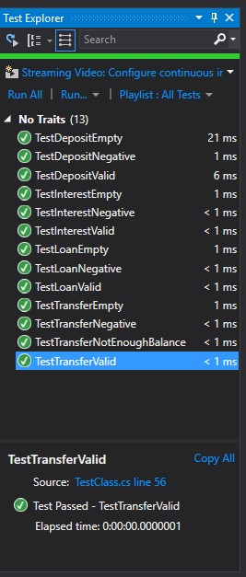

Website Pages – Screenshot:

1)Deposit

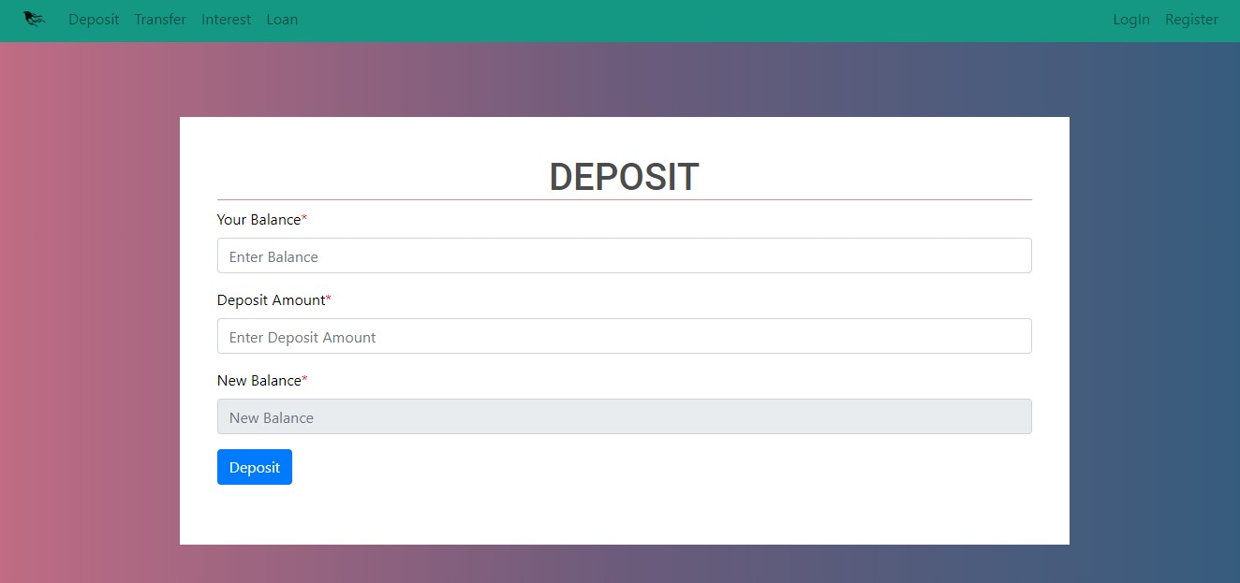

2)Transfer

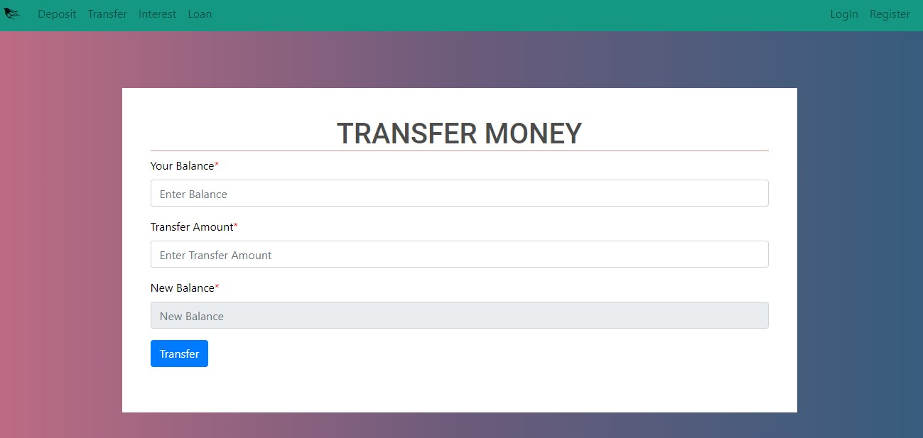

3)Interest

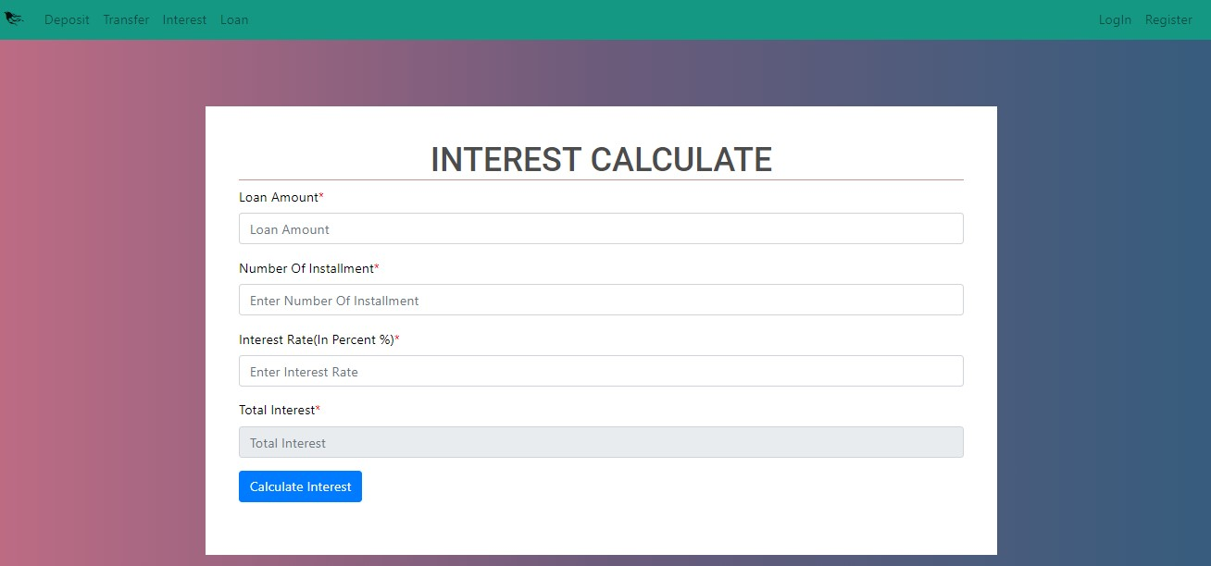

4)Loan